H.T No
Regulations:
A18

Sreenidhi Institute of Science and Technology
(An Autonomous Institution)
Code No: 7AC02 Date: 02-Nov-2021 (AN)

B.Tech I-Year II- Semester External Examination, Oct/Nov-2021 (Supplementary)
NETWORK ANALYSIS (ECM)

Time: 3 Hours Max.Marks:70

Note: a) No additional answer sheets will be provided.
b) All sub-parts of a question must be answered at one place only, otherwise it will not be valued.
c) Missing data can be assumed suitably.

ANSWER ANY 5 OUT OF 8 QUESTIONS. EACH QUESTION CARRIES 14 MARKS.

Bloom's Cognitive Levels of Learning (BCLL)

Remember | L1 | Apply | L3 | Evaluate | L5
Understand | L2 | Analyze | L4 | Create | L6

 |  |  | BCLL | CO(s) | Marks
1. | a) | State and explain the following types of networks.  i. Unilateral and Bilateral Networks ii. Linear and Non-Linear Circuits  iii. Active and Passive Networks iv Lumped and Distributed Networks | L2 | CO1 | [7M]
 | b) | In the following network find the power loss in 1Ω resistor.  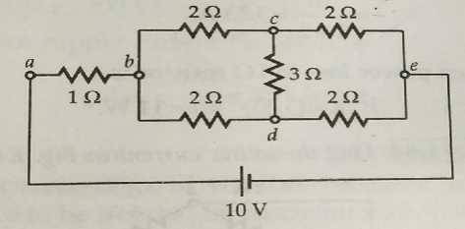 | L5 | CO1 | [7M]
2. | a) | Define: i) RMS value ii) Average Value iii) Form factor iv) Peak factor | L1 | CO2 | [7M]
 | b) | For the periodic waveform shown in the figure below, Determine  i) Frequency of the waveform ii) RMS value  iii) Average value iv) Form Factor  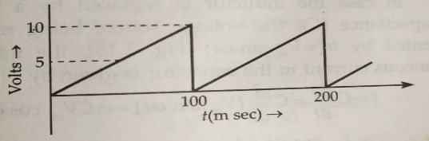 | L3 | CO2 | [7M]
3. | a) | i) Define Self and Mutual Inductance.  ii. Distinguish between Electrical and Magnetic Circuits. | L1  L2 | CO3 | [7M]
 | b) | Find the input impedance and the net inductance of the coupled circuit shown in below figure.  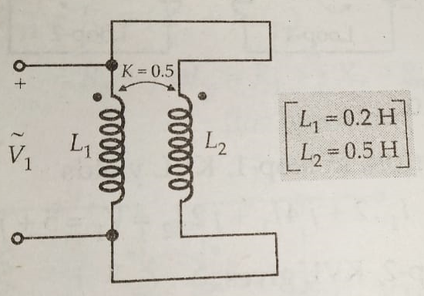 | L4 | CO3 | [7M]
4. | a) | State Thevenin’s Theorem and Obtain Thevenin’s equivalent circuit across x-y terminals in the following figure.  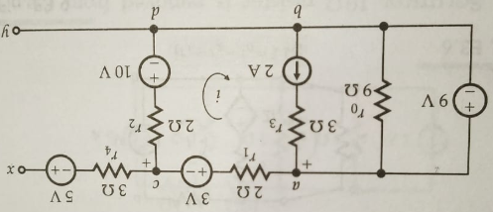 | L1  L6 | CO4 | [7M]
 | b) | State Milliman’s theorem and find the value of “R” to have the maximum power transfer in the circuit of the figure shown below, and also obtain the amount of maximum power.  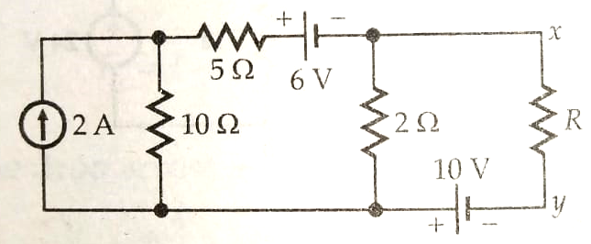 | L5 | CO4 | [7M]
5. | a) | Derive ABCD parameters of a Two-port network. | L6 | CO5 | [7M]
 | b) | Determine the Z-Parameters of the network shown below.  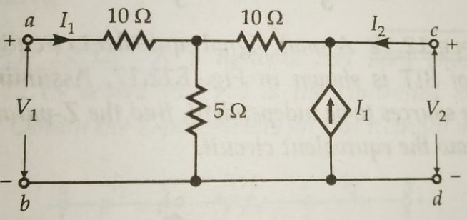 | L5 | CO5 | [7M]
6. | a) | i) A coil having resistance of 10Ω and inductance of 1H is switched on to a direct voltage of 100V. Calculate the rate of change of the current at the instant of closing the switch, when t=L/R and the steady state value of the current. | L4 | CO6 | [7M]
 | b) | Obtain the current at t>0, if a.c. voltage(v) is applied when the switch(K) is moved to 2 from 1 at t=0. Assume a steady state current of 1A in the LR circuit when the switch was at position 1.  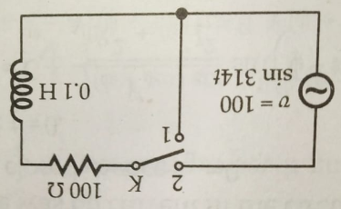 | L5 | CO6 | [7M]
7. | a) | Classify types of Energy Sources and explain each with an example. | L2 | CO1 | [7M]
 | b) | Determine source current(I), load current (I_{L}) and voltage drop across the Load Resistor(R_{L}) from the network below.  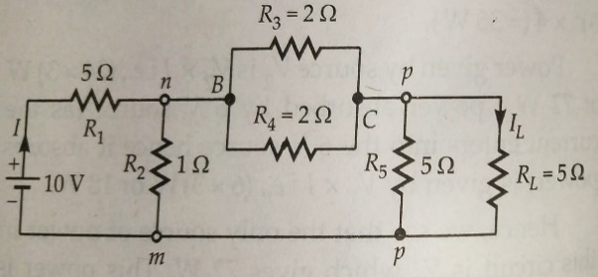 | L5 | CO2 | [7M]
8. | a) | The following Parallel RL circuit being energized by a sinusoidal AC voltage of V=100Sin(1000t+36°) volts. Obtain instantaneous current through R and L. Hence obtain the total current in terms of RMS values.  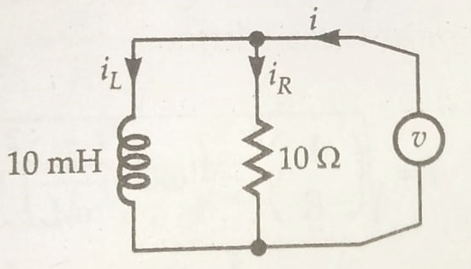 | L4 | CO4 | [7M]
 | b) | A 4Ω resistor is connected to a 10mH inductor in series across a 100V, 50Hz voltage source. Find,  i. Impedance of the circuit ii. Input Current  iii. Drop across the resistor and inductance. iv. Power Factor of the circuit.  v. Real power consumed in the circuit. vi. Total power supplied. | L5 | CO5 | [7M]
-- 00 -- 00 –

